Мастер – класс
«Развитие медийной грамотности на уроке английского языка»
Основные термины:
- Медиа — обширное понятие, включающее в себя средства коммуникации, способы передачи информации, а также образовываемую ими среду (медиапространство).
- Интермедиальность — это «специфическая форма диалога культур, осуществляемая посредством взаимодействия художественных образов или стилистических приёмов, имеющих для каждой конкретной эпохи знаковый характер».
- Экфрасис – описание произведения изобразительного искусства или архитектуры в изобразительном тексте.
Ход мастер-класса:
- Работа с картиной и стихотворением У. Блейка
The Ancient of Days  William Blake  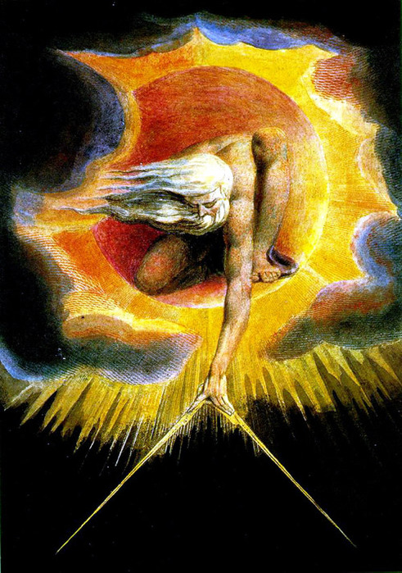 | The Tiger  By William Blake  Tiger Tiger. Burning bright,  In the forests of the night;  What immortal hand or eye.  Could frame thy fearful symmetry?  In what distant deeps or skies.  Burnt the fire of thine eyes?  On what wings dare he aspire?  What the hand, dare seize the fire?  And what shoulder, & what art,  Could twist the sinews of thy heart?  And when thy heart began to beat.  What dread hand? & what dread feet?  What the hammer? what the chain,  In what furnace was thy brain?  What the anvil? what dread grasp.  Dare its deadly terrors clasp?  When the stars threw down their spears  And watered heaven with their tears:  Did he smile His work to see?  Did he who made the lamb make thee?  Tiger Tiger burning bright,  In the forests of the night:  What immortal hand or eye,  Dare frame thy fearful symmetry?

*Questions to discuss:
The painting | The poem
- How would you explain the name of the picture? Who, to your mind, is depicted in it?  - What is he doing?  - Which hand (left or right) does he use to create?  - How can it be explained taking into consideration that to be left handed means to be right brained?  - What instrument does he have in his hand?  - What profession is it associated with?  - What figure is he drawing? What can it symbolize?  - Are there any similar shapes in the painting? What do you see in the background of the painting?  - Is the creator limited by some shape?  - What details in the picture show that he can break the limits?  - How can you explain the Russian equivalent of the name of the painting – the great architect?  - What is the message of the painting? | - Why is the central image of the poem a tiger?  - What colours can you think of reading the lines “Burning bright, In the forests of the night;”?  - Can you see similar colours in the painting?  - What other words or lines in the poem convey the same colour scheme?  - Why is the tiger described as possessing “fearful symmetry”? What are the two contrasts of its nature? Why is fire associated with the tiger?  - Who is the second character of the poem?  - What myths does William Blake allude to in this poem? Why?  - Does the author answer the question who created the tiger? Why?  - What is the message of the poem?  - How are the tiger and the architect similar? Different? Why?
*Text by Natalya Sukhanova
2. Работа с картиной Д. Тернера и стихотворением Д. Томсона (иллюстрация экфрасиса)
The Slave Ship  J. M. Turner  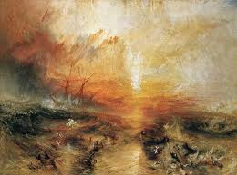 | Summer [excerpt]  by James Thomson  Increasing still the terrors of these storms,  His jaws horrific arm’d with threefold fate,  Here dwells the direful Shark. Lured by the scent  Of steaming crowds, of rank disease, and death,  Behold, he, rushing, cuts the briny flood,  Swift as the Gale can bear the ship along;  And, from the partners of that cruel trade,  Which spoils unhappy Guinea of her sons,  Demands his share of prey—demands themselves.  The stormy Fates descend: one death involves  Tyrants and slaves; when straight, their mangled limbs сrashing at once, he dyes the purple seas  With gore, and riots in the vengeful meal.

References:
Threefold – тройной, в три ряда
to lure – соблазнять, приманивать
Rank (disease) – дурно пахнущие
Behold – смотри, вот
Gale - буря
Mangled limbs – искалеченные конечности
Gore – кровь
to riot – буйствовать

*Questions to discuss:
The painting | The poem
- Describe the weather and the sea (calm, stormy, rough)  - What is depicted in the foreground?  - Why is the sea much harder in the left part of the painting? What effect does it create? How is the sea different on the right side?  - What colour are the clouds? What does the scarlet colour mean? Does it mean something?  - Who is more powerful – the nature or the man?  - If you could divide the painting into some parts vertically and horizontally, what figure would it be? Why?  - Another title of the painting is Typhoon coming on. How can you encounter for it?  - What feeling does the painting arise? | - What is the main image of the poem?  - How is it characterized?  - Which words describe its movement?  - How does it eat the prey?  - What semantic field do the words arm’d, cuts, share of prey, death, crashing belong to? Why?  - What atmosphere do these words create?  - How is the sea described? What is its colour? Why?  - How does the motif of fate work in the poem?  - How is the same motif evident in the picture?  - What feelings does the author arise?
*by Natalya Sukhanova
- Reflection.
How can the poems help you decipher the message of the paintings?

- Leave-out task:
- Think of three positive aspects of working with different sources of media
- Think of two difficult aspects and ways to cope with them
- Think of one lesson / topic you can implement this kind of work in.
Bibliography
- www.wikipedia.org
- Яценко Е.В. «Любите живопись, поэты…». Экфрасис как художественно-мировоззренческая модель. 2011
- Delaney Denis “Fields of Vision” 2005

