Набатова Ольга Александровна, учитель начальных классов
МАОУ «СОШ №84» г. Перми
Семинар "Формирование межкультурной компетентности обучающихся путем создания иноязычной среды в общеобразовательной школе"
19 февраля 2014 года
Конспект внеурочного занятия «Пищевые цепочки» в рамках реализации краткосрочного курса «Amazing world of animals».
Данный курс разработан в рамках реализации проекта CLIL (изучение предмета на иностранном языке). На занятии ребятам было предложено посмотреть видео, из которого дети должны были запомнить называния групп животных по типу питания (травоядные, хищники и всеядные). Затем дети с помощью диаграммы Венна классифицировали животных. После введения понятия «пищевая цепочка» ребята получили карточку с изображением животного, задача была – найти остальных зверей из пищевой цепи. После выполнения задания образовалось четыре группы, ставшие проектными, где ребята создавали мобильную пищевую цепь. При помощи изображений с животными, цветной бумаги, ленточек и вешалки дети соорудили необычный продукт.

Food chains.
Aim:
• To know what a food chain is.
• To identify the different parts of a food chain.
Teaching Objectives  What I plan to teach |  | Learning Outcomes  What learners will be able to do  at the end of the lesson
Content  - Revise previous knowledge.  - Explain what a food chain is: definition, elements and how they combine to create food webs.  - Explain what happens when a part of a food chain disappears. |  | Content  - Describe what a food chain is.  - Explain the relationship between the different organisms of a food chain.  - Create a food chain with the different organisms (producers, consumers and decomposers).
Cognition  - Classify different living organisms according to their similarities.  - Identify the elements of a food chain.  - Explain what happens when a part of a food chain disappears.  - Understand key concepts and apply to them. |  | Cognition  • Classify different living organisms according to own criteria.  • Complete different food chains through a game.  • Choose a specific food chain to work in a group and discuss it.  • Create a food chain and explain the process.  • Predict what happens when a part of a food chain disappears.  • Memorize key language and apply it. (use it)  • Transfer key language.
Communication
Language of learning

Key sentences needed
• Have you got …? Yes, I have / No, I haven’t
• The … is eaten by the … .
• The … is a producer / consumer.
• The … is a herbivore / carnivore / omnivore.
Key vocabulary
• frog, snake, owl, seal, polar bear, plant, spider, cat, turtle, alligator, producer, consumer, decomposer, herbivore, carnivore, omnivore.

Teacher | Learners |  | Timing
-Hello! I am glad to see you! | - We are glad to see you too!
-Sit down please.
-Today we are going to classify animals according to their eating habits. There are three groups of animals.  -Let’s watch a short video about them. Try to remember the names of the groups. |  |  | 2 min
-Can you name three groups of animals?  - What does a herbivore eat?  -What does a carnivore eat?  -What does an omnivore eat? | - Herbivore, carnivore and omnivore (слова вывешиваю на доску)  - Grass, plants.  - Meat.  -Grass and meat, all.
-Look on the board, please. It’s Venn diagram. Let’s classify animals.  - Who can do it? You are welcome.  (Pic. 1) | Children work on the white board one by one.  -Tiger! It’s a carnivore.  -Camel! It’s a herbivore.  etc.  Zebra is a herbivore. |  | - min
-Let’s add some animals in your diagram. Let’s play game “Draw or Act”. Lisa, come here. Choose one card please. Ok, you will draw…(choose another card)  All the rest, you will guess the animal and say, is it a carnivore or a herbivore. | -Cat! It’s an omnivore.  -Pig! It’s a herbivore. |  | 3 min
-Plants use sunlight, carbon dioxide and water for producing energy. A giraffe eats plants. A lion eats the giraffe. It’s called a food chain. In the food chain plants are producers, giraffes and lions are consumers. When lions die, they are decomposing in soil by bacteria. Bacteria are decomposers.

-Let’s play the game. You have a card. You have to find the other members of your food chain. You have 1 minute. If you are ready, stand in line near the board.  - Who are you? | -I’m a grass. I’m eaten by a rabbit.  -I’m a rabbit. I’m eaten by a fox.  - I am a fox.  -I’m plankton. I’m eaten by a shrimp.  -I’m a shrimp. I’m eaten by a fish.  -I’m a fish. I’m eaten by a shark.  -I’m a shark. I’m eaten by a human.  - I’m a human.  -I’m a plant. I’m eaten by a mouse.  - I’m a mouse. I’m eaten by a snake.  - I’m a snake. I’m eaten by an owl.  - I’m an owl. |  | 4 min
Divide into three groups.  You have pictures of plants and animals. Organize them into food chains, writing their names and labeling their role in the food chain. Put the picture on a red sheet of paper if it’s a consumer, on a green one if it’s a producer, on a brown sheet of paper, if it’s a decomposer. You have to make one mobile food chain. You have 3 minutes. | Children are making the project and presenting it to the rest of the class.  A rabbit eats a plant.  A fox eats a rabbit.  Bacteria eat a fox.  A zebra eats a plant.  A lion eats a zebra.  Bacteria eat a lion.  A hamster eats a plant.  An owl eats a hamster.  Bacteria eat an owl. |  | 5 min
Thank you. The lesson is over. Goodbye.

Опорные слова и конструкции на доске:
herbivore
It is a (an) carnivore
omnivore
I’m eaten by a …
A cat eats a mouse.
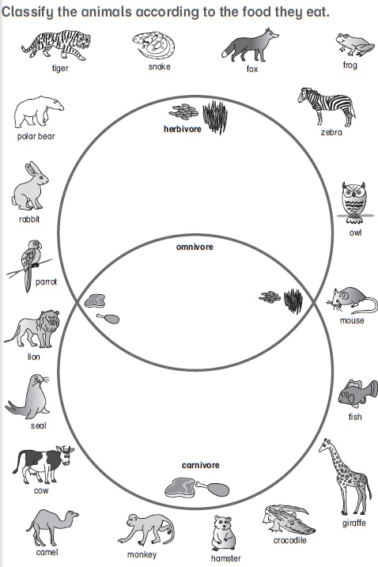

Pic. 1

Example of the game “Make a food chain”
You are grass.  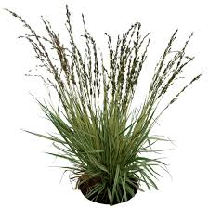  You are eaten by a rabbit. | You are rabbit.  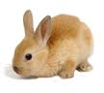  You are eaten by a fox. | You are fox.  