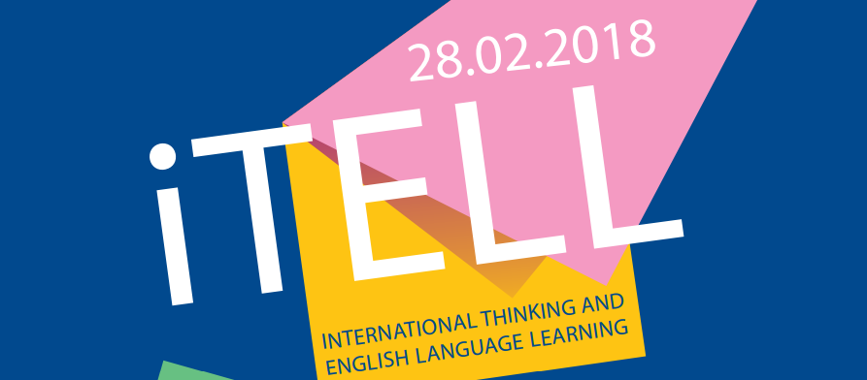
Conference opening 15.00
27 Lebedeva str.
SESSION 1. Society and Language. ROOM 310
№ | SPEAKER | GROUP | TOPIC
1 | Ситрова Карина | Ю-16-2 | Effective Protection of Women’s Rights Under International Law
2 | Тудакова Екатерина | Ю-15-2 | Correlation of Labour and Civil Contract
3 | Гоголев Степан | Э-16-1 | Why the poor pay more for food?
4 | Волегова Александра | "Лицей №2" | The Creation of Mystical Atmosphere in Agatha Christie’s Detective Stories
5 | Бахматов Андрей | "Лицей №2" | English Slang as a Key to Effective Communication
6 | Воробьева Елена | "Лицей №2" | Irish and British Dialects: What Are the Differences
7 | Шатова Мария | "Лицей №2" | Social and Cultural Competence as a Guide to Effective Business Negotiations
8 | Паршаков Александр,  Яцков Григорий | БИ-16-1 | Edging Closer to Authoritarianism or a Momentary Democracy-setback?
9 | Голдобин Алексей | БИ-16-2 | The Influence of Chess in XX century

SESSION 2. Health. Medicine. Science. ROOM 207
№ | SPEAKER | GROUP | TOPIC
1 | Воронова Анна | ПГМУ им. Е.А.Вагнера | The Evaluation of Socially Excluded People Health Status
2 | Ермолаева Светлана | ПИ-16-1 | Mirror Neurons
3 | Третьяк Юлия | Э-16-1 | Sleep Deprivation Trend
4 | Шафранская Анастасия,  Лебедева Алёна | БИ-17-1 | Polyphasic Sleep: Whimsicality of Eccentrics or Priceless Breakthrough?
5 | Алексеенок Максим | "Лицей №2" | The Impact of Street Workout on Physical and Moral Development of Teenagers
6 | Савельева Маргарита | БИ-16-2 | Integration of People with Autism, Especially Asperger-Syndrome in Society and Economy
7 | Алексеева Анастасия,  Соловьёв Артём | БИ-16-2 | Exploring the Galaxy: The Most Interesting Discoveries

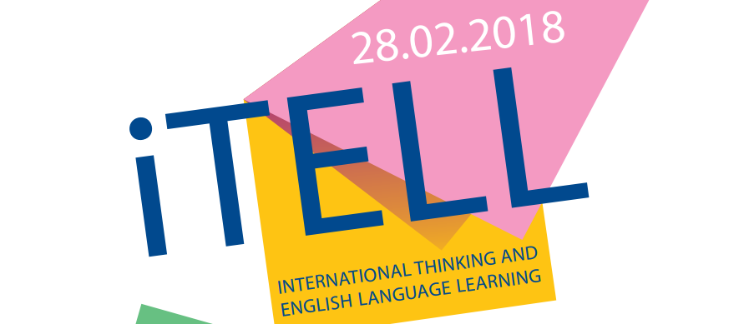
Conference opening 15.00
27 Lebedeva str.
SESSION 3. Education and Learning. ROOM 304
№ | SPEAKER | GROUP | TOPIC
1 | Кустова Ольга | Э-16-1 | The Science of Effective Learning
2 | Горбунова Софья | МАОУ "Лицей №2" | Free Education Facilities for Studying Abroad
3 | Вяткин Никита | ПИ-16-1 | The Inability of Universities to Create Millionaires
4 | Старцев Даниил | ПИ-16-1 | Educational Origami
5 | Федянин Андрей | ПИ-17-2 | The Interconnection between Students' Progress in Studies and the Quality of Their Program Code
6 | Кузнецова Дарья, Копытов Степан | ПИ-17-2 | Anticipatory Failure Determination of Educational Process in the Higher School of Economics
7 | Рзаева Адила | БИ-16-2 | Computer Games as an Effective Way of Teaching Children

SESSION 4. Economics and IT. ROOM 301
№ | SPEAKER | GROUP | TOPIC
1 | Гильман Максим | ПИ-16-1 | Computer Vision: Algorithms, Usage, Implementation Difficulties
2 | Пласкевич Анастасия, Холодницкий Сергей | БИ-16-1 | Machine Learning Application
3 | Тетерина Дарья | Э-14-2 | Methods of Machine Learning for Censored Demand Prediction
4 | Терлыч Никита, Сунцев Максим | ПИ-16-1 | Tourism Application Development
5 | Гордиенко Анастасия | Э-14-2 | Influence of Daylight Saving Time Cancellation on Electricity Load
6 | Мирошниченко Виктория | Э-17-2 | The Impact of Refugees on the Economies of Hosting European Countries: a Case Study of the Federal Republic of Germany
7 | Кучева Ирина, Ткачёва Полина | М-17-1 | Coffee Houses Target Audience
8 | Баленко Валерия | Э-16-2 | Food of the Future

